Manuel test for Assignment 3.0

Open the app and this interface will show up

Profile Page:

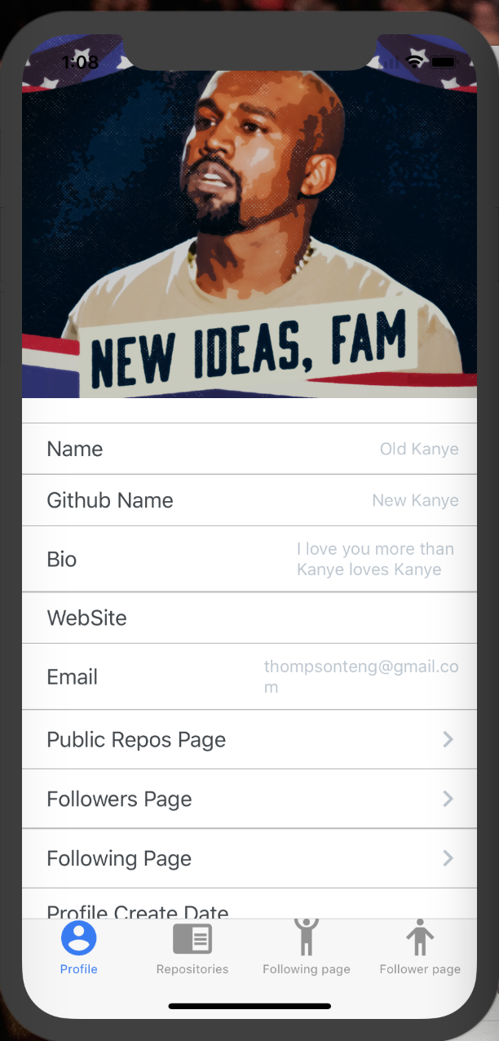

Public Repos Page on Profile page will direct you to Repositories page, Followers Page will direct you to Follower Page and Following Page will direct you to Following Page.

Repos Page:

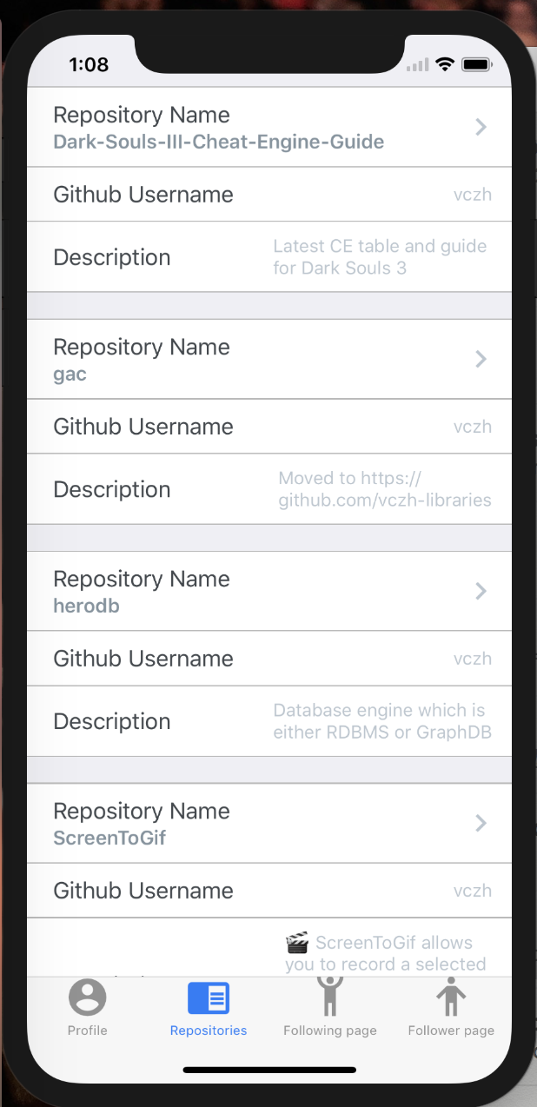

Here it will show a list of available repositories from the user’s Github page. And if you click on the chevron, it will redirect you to the Github page of the project.